West 6700
1/16 DIN Limit Alarm Unit




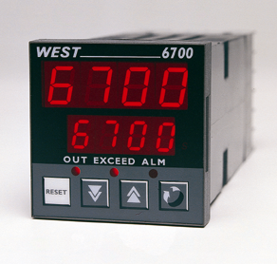
 | The West 6700 provides a programmable safety cut out with optional outputs for annunciators and alarms. A latched relay cuts power to the process if it exceeds the safe value. The unit must be reset before the process can continue.
 | - High or low trip | - Exceed & relay indicators
 | - 5 amp latched relay | - Configuration via PC
 | - Remote reset option | - RS485 comms
 | - 2 Annunciators or alarms | - PV retransmit option

Technical Data

Features
Output Configuration | Up to 3 Total. 1 latching trip relay, max 2 alarms relays,  max 1 DC linear retransmit (PV or limit value)
Alarm 1 & 2 Types | Process high, process low, setpoint deviation, band, logical OR alarms or trip annunciator.
Limit Action | Latching relay output when PV exceeds set value. Selectable for high or low trip activation.
Output Reset Action | Limit output can be reset only when exceed condition is absent. Local or remote reset options.
Annunciator Reset Action | Annunciator output can be reset at any time. Local or remote reset options.
Human Interface | 4 button operation, dual 4 digit 10mm & 8mm high LED displays. Exceed, output & alarm indicators
PC Configuration | Off-line configuration from serial port to dedicated config socket (comms option not required)

Input
Thermocouple | J, K, R, S, T, B, L, & N.
RTD | 3 Wire PT100, 50Ω per lead maximum (balanced)
DC Linear | 0-20/4-20mA, 0-50/10-50mV, 0-5/1-5/0-10/2-10V. Scaleable -1999 to 9999, dec point available
Impedance | >100MΩ for Thermocouple and mV ranges, 47KΩ for V ranges and 4.7Ω for mA ranges
Accuracy | +/- 0.25% of input span +/- 1 LSD (T/C CJC better than 0.7°C)
Sampling | 4 per second, 14 bit resolution approximately
Sensor Break Detection | <2 secs (except zero based DC ranges), control O/P’s turn off, high alarms activate for T/C and mV ranges, low alarms activate for RTD, mA or V ranges.

Outputs & Options
Limit Trip Relay | Contacts SPDT 5Amp resistive at 240V AC, >100,000 operations
Alarm Relays | Contacts SPDT 2Amp resistive at 240V AC, >500,000 operations
Retransmit Outputs | 0-20/4-20mA into 500Ω max, 0-10/0-5V into 500Ω min. Accuracy typically +/- 0.25%
Communications | 2 Wire RS485, 1200 to 9600 Baud, West ASCII
Remote reset option | Allows remote latched relay and annunciator reset, using volt free or TTL  input (Reset = -0.6 to 0.8V, or contact closure)
Operating & Environmental
Temperature & RH | 0 to 55°C (-20 to 80°C storage), 20% to 95%RH non-condensing
Power Supply | 90 to 264V 50/60Hz (optional 20 to 55V AC/22 to 65V DC), approx 4 Watts
Front Panel Protection | IEC IP66 (Behind panel protection is IP20)
Approvals and Certification | CE, UL & Ulc & FM

110mm
48mm
45mm +0.5
45mm +0.5
48mm
10mm (approx)

Dimensions

Panel Cut-out

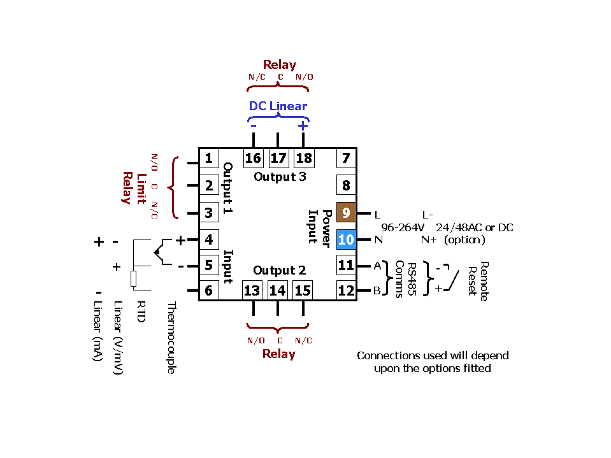

Field Reconfiguration

Connection Details

Input
Configurable to any type, no extra parts required

Output 1
Type is fixed as Limit Relay

Output 2
Configurable as Alarm or Annunciator, via plug-in Relay

Output 3
Configurable as Alarm or Annunciator via plug-in Relay, or retransmit using DC Linear module

Option Slot
Configurable as RS485 comms or Remote Reset, via plug-in modules

Order Code | N6700 | - | x | - | x | - | x | - | x | - | xx

 | Input type |  |  | Options and Power Supply
 | 3 Wire RTD or DC mV | 1 |  |  | 00 | No Options/90-264V AC line supply
 | Thermocouple | 2 |  |  | 02 | No Options/24-48V AC or DC line supply
 | DC mA | 3 |  |  | 10 | RS485 Comms/90-264V AC line supply
 | DC Voltage | 4 |  |  | 12 | RS485 Comms/24-48V AC or DC supply
 |  |  |  |  | 30 | Remote Reset/90-264V AC line supply
 |  |  |  |  | 32 | Remote Reset /24-48V AC or DC supply
 | Output 1 |  |  |  |  | Output 3
 | Limit Relay | 1 |  |  | 0 | Not fitted
 |  |  |  |  | 1 | Relay Alarm 1 or Annunciator
 |  |  |  |  | 3 | DC 0-10V Re-Transmit PV or SP
 | Output 2 |  |  |  | 4 | DC 0-20mA Re-Transmit PV or SP
 | Not fitted | 0 |  |  | 5 | DC 0-5V Re-Transmit PV or SP
 | Relay Alarm 2 or Annunciator | 1 |  |  | 7 | DC 4-20mA Re-Transmit PV or SP

In accordance with our policy of continuous improvement, we reserve the right to change specifications from those shown in this document.

West Instruments Ltd

The Hyde Business Park Tel: +44 (0)1273 606271

Brighton, BN2 4JU Fax: +44 (0)1273 609990

East Sussex e-mail: info@west-inst.co.uk

England www.west-inst.co.uk

