West 6120
1/16 DIN Easy Use Controller

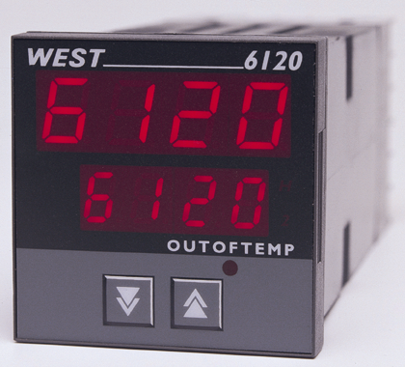


 | The West 6120 is a full featured 1/16 DIN controller. Designed for applications requiring protection from operator errors, setpoint adjustment can be locked or limited to a narrow band.
 | - Tamper proof | - Heat/Cool operation
 | - Two process alarms | - Ramping setpoint
 | - Loop alarm | - Dual setpoint selection
 | - RS485 comms | - Configuration via PC

Technical Data

Features
Control Types | Full PID with Auto Pre-tune, Self-tune, Manual Tuning, or On-Off control. Heat only or heat/cool mode
Output Configuration | Up to 3 Total. Max 2 for control (Heat/Heat & Cool), max 2 for Alarms,  max 1 for retransmit Process Value or Setpoint
Alarm 1 & 2 Types | Process high, process low, SP deviation, band, logical OR and hysteresis. Also 1 loop alarm
Human Interface | 2 button operation, dual 4 digit 10mm & 8mm high LED displays, plus alarm indicator
Setpoint Locking | Front panel setpoint adjustment – Full, limited or none (selectable)
PC Configuration | Configuration via PC only. Dedicated config socket (controller comms option not required)

Input
Thermocouple | J, K, R, S, T, B, L, & N.
RTD | 3 Wire PT100, 50Ω per lead maximum (balanced)
DC Linear | 0-20/4-20mA, 0-50/10-50mV, 0-5/1-5/0-10/2-10V. Scaleable -1999 to 9999, dec point available
Impedance | >100MΩ for Thermocouple and mV ranges, 47KΩ for V ranges and 4.7Ω for mA ranges
Accuracy | +/- 0.25% of input span +/- 1 LSD (T/C CJC better than 0.7°C)
Sampling | 4 per second, 14 bit resolution approximately
Sensor Break Detection | <2 secs (except zero based DC ranges), control O/P’s turn off, high alarms activate for T/C and mV ranges, low alarms activate for RTD, mA or V ranges.

Outputs & Options
Control & Alarm Relays | Contacts SPDT 2Amp resistive at 240V AC, >500,000 operations
Control SSR Outputs | Drive capability >4.2V DC in 1KΩ (10V 500Ω version available)
Solid State (Triac) Outputs | 0.01 to 1 Amp AC 20 to 280V, 47 to 63Hz
Control DC Outputs | 0-20/4-20mA into 500Ω max, 0-10/0-5V into 500Ω min. Accuracy typically +/- 0.5%
Retransmit Outputs | 0-20/4-20mA into 500Ω max, 0-10/0-5V into 500Ω min. Accuracy typically +/- 0.25%
Communications | 2 Wire RS485, 1200 to 9600 Baud, West ASCII (Modbus Optional)
Dual Setpoint Selection | Selects between 2 SP’s using volt free or TTL input (SP1 = -0.6 to 0.8V, SP2 = 2 to 24V)
Operating & Environmental
Temperature & RH | 0 to 55°C (-20 to 80°C storage), 20% to 95%RH non-condensing
Power Supply | 90 to 264V 50/60Hz (optional 20 to 55V AC/22 to 65V DC), approx 4 Watts
Front Panel Protection | IEC IP66 (Behind panel protection is IP20)
Approvals and Certification | CE, UL & ULc

PC Configuration Software: Runs on DOS or Windows 95/98. Includes connection cable. Part Number M9997-A05011

110mm
48mm
45mm +0.5
45mm +0.5
48mm
10mm (approx)

Dimensions

Panel Cut-out

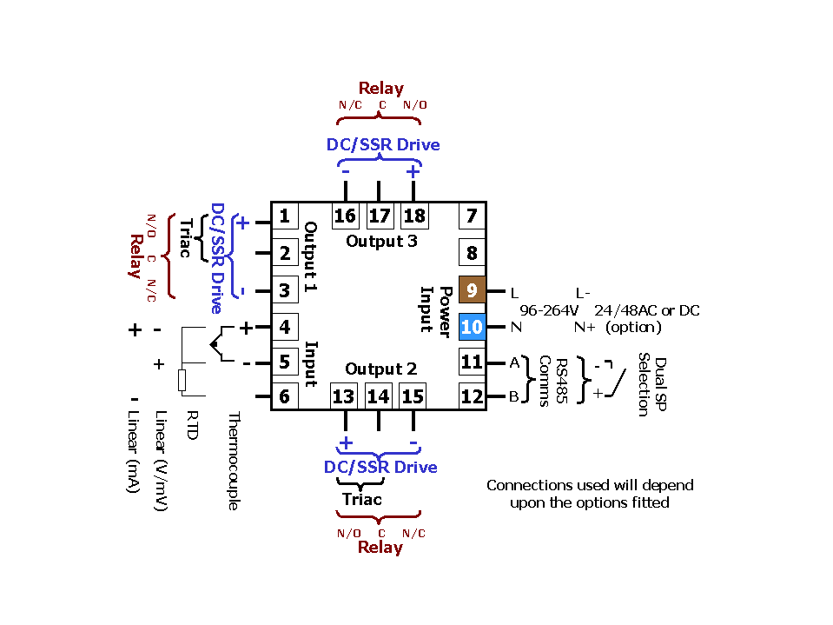

Field Reconfiguration

Connection Details

Input
Configurable to any type, no extra parts required

Output 1
Type is fixed as ordered. Either Relay/SSR (selectable), Triac or DC Linear (selectable for mV, mA, Volts)

Output 2
Configurable as Cool O/P or Alarm via plug-in Relay, SSR, Triac or DC Linear modules

Output 3
Configurable as Alarm via plug-in Relay or SSR modules, or retransmit using DC Linear module

Option Slot
Configurable as RS485 comms or dual setpoint selection, via plug-in modules

Order Code | N6120 | - | x | - | x | - | x | - | x | - | xx | - | xxx

 | Input type |  |  | Special Variants
 | 3 Wire RTD or DC mV | 1 |  |  | Blank | Special Variant not required
 | Thermocouple | 2 |  |  | S09 | MODBUS instead of West ASCII
 | DC mA | 3 |  |  |  | (requires RS485 option)
 | DC Voltage | 4 |  |  | S14 | 10V DC SSR outputs
 | Output 1 |  |  |  |  | (requires SSR output codes)
 | Relay Control | 1
 | DC for SSR Control | 2 |  |  |  | Options and Power Supply
 | DC 0-10V Control | 3 |  |  | 00 | No Options/90-264V AC line supply
 | DC 0-20mA Control | 4 |  |  | 02 | No Options/24-48V AC or DC line supply
 | DC 0-5V SP Control | 5 |  |  | 10 | RS485 Comms/90-264V AC line supply
 | DC 4-20mA Control | 7 |  |  | 12 | RS485 Comms/24-48V AC or DC supply
 | Triac Control | 8 |  |  | 30 | Dual Setpoint/90-264V AC line supply
 | Output 2 |  |  |  | 32 | Dual Setpoint/24-48V AC or DC supply
 | Not fitted | 0 |  |  |  | Output 3
 | Relay Control or Alarm 2 | 1 |  |  | 0 | Not fitted
 | DC for SSR Control or Alarm 2 | 2 |  |  | 1 | Relay Alarm 1 output
 | DC 0-10V Control | 3 |  |  | 2 | DC for SSR Alarm 1 output
 | DC 0-20mA Control | 4 |  |  | 3 | DC 0-10V Re-Transmit PV or SP
 | DC 0-5V Control | 5 |  |  | 4 | DC 0-20mA Re-Transmit PV or SP
 | DC 4-20mA Control | 7 |  |  | 5 | DC 0-5V Re-Transmit PV or SP
 | Triac Control | 8 |  |  | 7 | DC 4-20mA Re-Transmit PV or SP

In accordance with our policy of continuous improvement, we reserve the right to change specifications from those shown in this document.

West Instruments Ltd

The Hyde Business Park Tel: +44 (0)1273 606271

Brighton, BN2 4JU Fax: +44 (0)1273 609990

East Sussex e-mail: info@west-inst.co.uk

England www.west-inst.co.uk

