¹/₁₆ - ¹/₈ - ¹/₄ DIN LIMIT CONTROLLERS
CONCISE PRODUCT MANUAL (59333-1)
CAUTION: Installation should be only performed by technically competent personnel. Local Regulations regarding electrical installation & safety must be observed.

INSTALLATION
The models covered by this manual have three different DIN case sizes (refer to section 9). Some installation details vary between models. These differences have been clearly shown.
Note: The functions described in sections 2 thru 8 are common to all models.

Installing Option Modules
¹/₁₆ Din Size Instruments
CPU PCB  Option Module 1  (Fixed Limit Relay)  Option Module 2 | 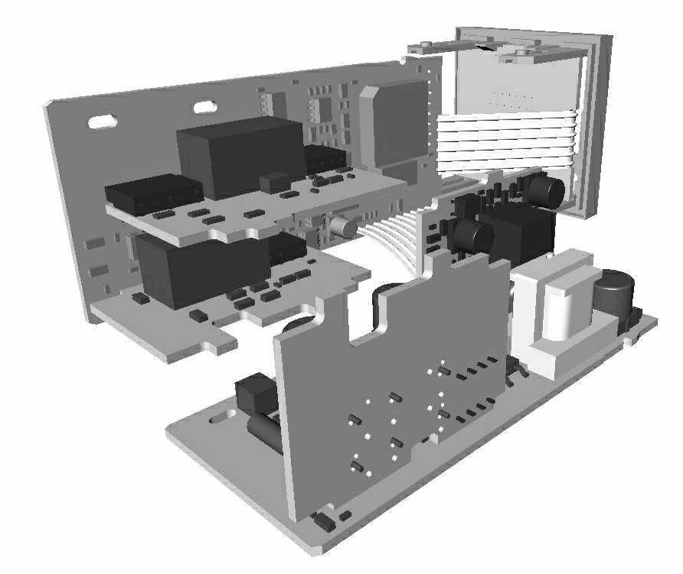 |  | Mounting Struts  Option Module A  Option Module 3  PSU PCB
¹/₈ & ¹/₄ Din Size Instruments
CPU PCB  Option Module B  (not used on Limit Controllers)  Option Module 2  Option Module 1  (Fixed Limit Relay) |  | 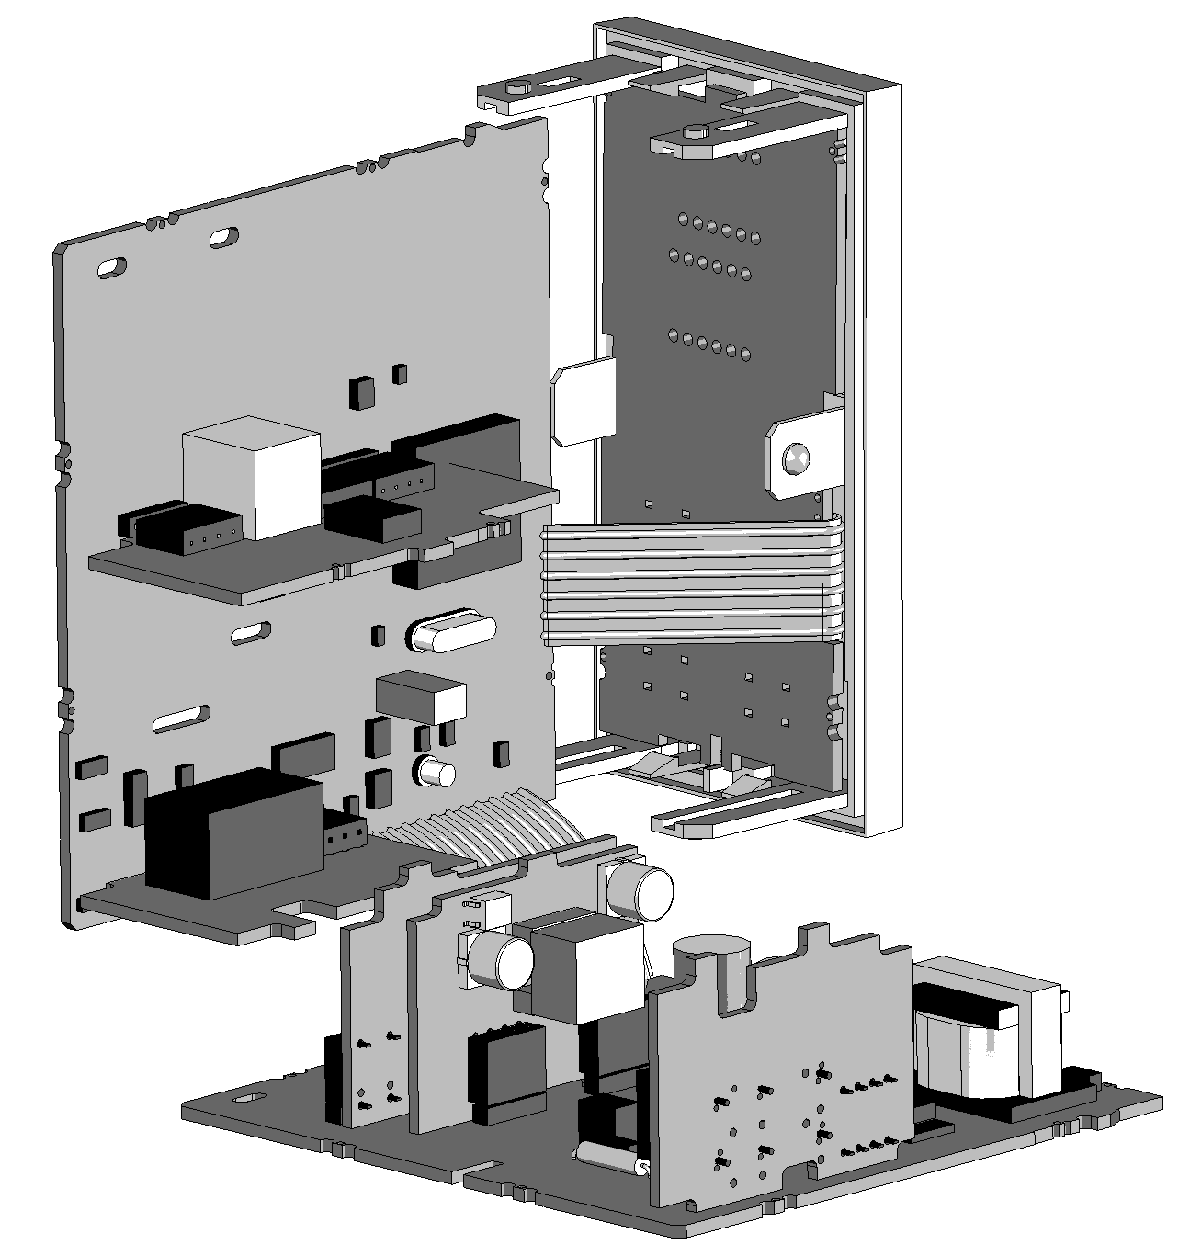 | Mounting Struts  Option Module A  Option Module 3  PSU PCB
To access module A, first detach the PSU and CPU boards from the front by lifting first the upper, and then lower mounting struts. Gently separate the boards.
- Plug the required option modules into the correct connectors, as shown below.
- Locate the module tongues in the corresponding slot on the opposite board.
- Hold the main boards together while relocating back on the mounting struts.
- Replace the instrument by aligning the CPU and PSU boards with their guides
in the housing, then slowly push the instrument back into position.
Note: Option modules are automatically detected at power up.

Option Module Connectors
¹/₁₆ Din Size Instruments
Option Slot 1  (Fixed Limit Relay)  Option Slot 2 Connector  PL4A | 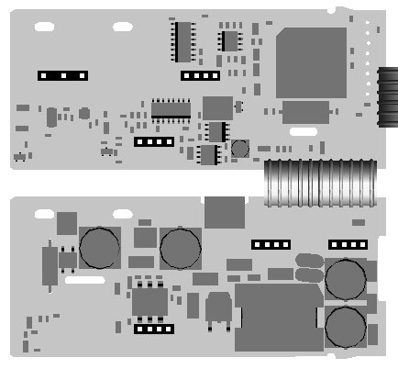 | Option Slot A Connectors  PL5 & PL6  Option Slot 3 Connector  PL4B
¹/₈ & ¹/₄ Din Size Instruments
Option Slot B (not used on Limit Controllers)  Option Slot 2 Connector  PL4A  Option Slot 1 (Fixed Limit Relay) | 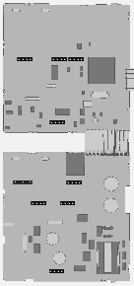 | Option Slot A Connectors PL5 & PL6  Option Slot 3 Connector  PL4B

Panel-Mounting  The mounting panel must be rigid, and may be up to 6.0mm (0.25inch) thick. Cut-out sizes are:  Cut-Out Dim A Cut-Out Dim B  ¹/₁₆ & ¹/₈ Din = 45mm ¹/₁₆ Din = 45mm  ¹/₄ Din = 92mm ¹/₈ & ¹/₄ Din = 92mm  For n multiple instruments mounted side-by-side, cut-out A is 48n-4mm (¹/₁₆ & ¹/₈ Din) or 96n-4mm (¹/₄ Din) | Tolerance +0.5, -0.0mm  A  B

Mounting Panel  Instrument  Housing  Ratchets  Gasket |  | 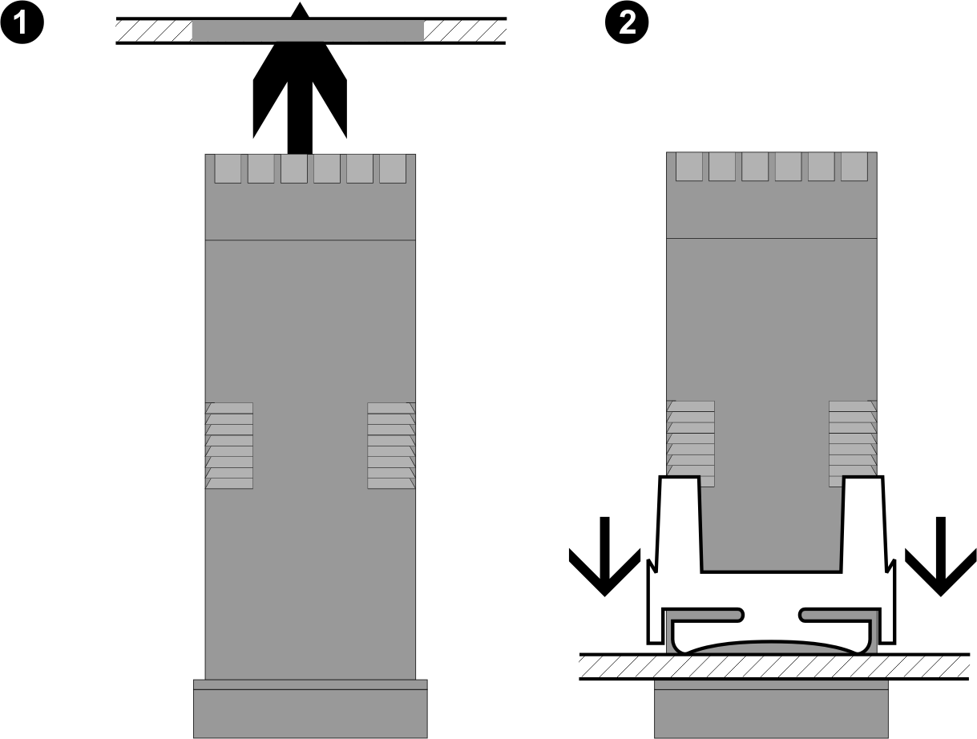 | Slide mounting clamp over the instrument housing towards rear face of mounting panel until the tongues engage in ratchets and instrument is clamped in position.  Hold instrument firmly in position (apply pressure to bezel only)
 | CAUTION: Do not remove the panel gasket; it is a seal against dust and moisture.

Rear Terminal Wiring
USE COPPER CONDUCTORS (EXCEPT FOR T/C INPUT)
Single Strand wire gauge: Max 1.2mm (18SWG)
¹/₁₆ Din Size Instruments
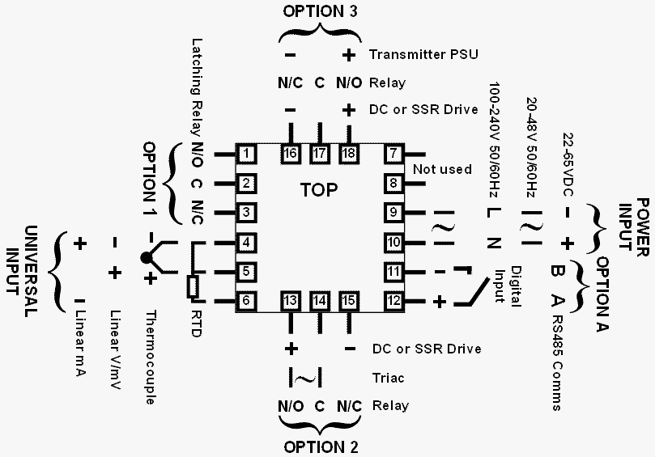
¹/₈ & ¹/₄ Din Size Instruments
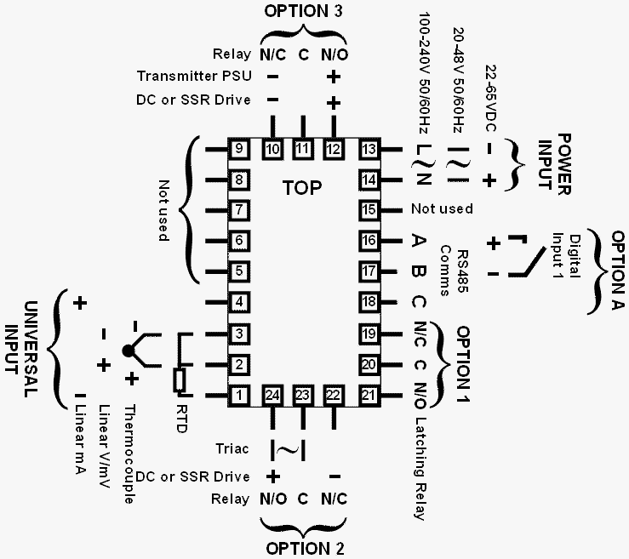
These diagrams show all possible option combinations. The actual connections required depends on the exact model and options fitted.
CAUTION: Check information label on housing for correct operating voltage before connecting supply to Power Input
Fuse: 100 – 240V ac – 1amp anti-surge
24/48V ac/dc – 315mA anti-surge
Note: At first power-up the message   is displayed, as described in section 6 of this manual. Access to other menus is denied until configuration mode is completed

SELECT MODE



Select mode is used to access the configuration and operation menu functions.
It can be accessed at any time by holding down and pressing .
In select mode, press or to choose the required mode, press to enter. An unlock code is required to prevent unauthorised entry to Configuration, & Setup modes. Press or to enter the unlock code, then press to proceed.
Mode | Upper  Display | Lower  Display | Description | Default Unlock Codes
Operator |  |  | Normal operation | None
Set Up |  |  | Tailor settings to the application | 
Configuration |  |  | Configure the instrument for use | 
Product Info |  |  | Check manufacturing information | None
Note: The instrument will always return automatically to Operator mode if there is no key activity for 2 minutes.

CONFIGURATION MODE
First select Configuration mode from Select mode (refer to section 2).
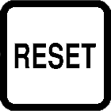
Press to scroll through the parameters, then press or to set the required value. Press to accept the change, otherwise parameter will revert to previous value. To exit from Configuration mode, hold down and press , to return to Select mode.
Note: Parameters displayed depends on how instrument has been configured. Refer to user guide (available from your supplier) for further details. Parameters marked * are repeated in Setup Mode.

Parameter |  | Lower Display | Upper Display |  |  | Adjustment range & Description |  |  | Default Value
Input Range/Type |  |  | See following table for possible codes |  |  |  |  |  | 
Code | Input Type & Range |  |  |  | Code | Input Type & Range | Code | Input Type &  Range
bC | B: 100 - 1824 ºC |  |  |  | L.C | L: 0.0 - 537.7 ºC | P24F | PtRh20% vs 40%:  32 - 3362 ºF
bF | B: 211 - 3315 ºF |  |  |  | L.F | L: 32.0 - 999.9 ºF | P24F
CC | C: 0 - 2320 ºC |  |  |  | NC | N: 0 - 1399 ºC | PTC | Pt100: –199 - 800 ºC
CF | C: 32 - 4208 ºF |  |  |  | NF | N: 32 - 2551 ºF | PtF | Pt100: –328 - 1472 ºF
JC | J: –200 - 1200 ºC |  |  |  | rC | R: 0 - 1759 ºC | Pt.C | Pt100: –128.8 - 537.7 ºC
JF | J: –328 - 2192 ºF |  |  |  | rF | R: 32 - 3198 ºF | Pt.F | Pt100: –199.9 - 999.9 ºF
j.C | J: –128.8 - 537.7 ºC |  |  |  | SC | S: 0 - 1762 ºC |  | 0 - 20 mA DC
j.F | J: –199.9 - 999.9 ºF |  |  |  | SF | S: 32 - 3204 ºF |  | 4 - 20 mA DC
KC | K: –240 - 1373 ºC |  |  |  | tC | T: –240 - 400 ºC |  | 0 - 50 mV DC
KF | K: –400 - 2503 ºF |  |  |  | tF | T: –400 - 752 ºF | . | 10 - 50 mV DC
k.C | K: –128.8 - 537.7 ºC |  |  |  | t.C | T: –128.8 - 400.0 ºC |  | 0 - 5 V DC
K.F | K: –199.9 - 999.9 ºF |  |  |  | t.F | T: –199.9 - 752.0 ºF |  | 1 - 5 V DC
LC | L: 0 - 762 ºC |  |  |  | P24C | PtRh20% vs. 40%:  0 - 1850 ºC |  | 0 - 10 V DC
LF | L: 32 - 1403 ºF |  |  |  | P24C | PtRh20% vs. 40%:  0 - 1850 ºC |  | 2 - 10 V DC
Note: Decimal point shown in table indicates temperature resolution of 0.1°
Parameter |  | Lower Display | Upper Display |  |  | Adjustment range & Description |  |  | Default Value
Scale Range Upper Limit |  | ☹ | Scale Range Lower Limit +100  to Range Maximum |  |  |  |  |  | Range max (Lin=1000)
Scale Range Lower Limit |  | ☹☹ | Range Minimum to  Scale Range Upper Limit -100 |  |  |  |  |  | Range min (Linear=0)
Decimal point position |  |  | =XXXX, =XXX.X, =XX.XX, =X.XXX  (non-temperature ranges only) |  |  |  |  |  | 
Process Variable Offset |  |  | ±Span of controller  (see CAUTION note at end of section) |  |  |  |  |  | 
Limit Action |  |  |  |  |  | High Limit.  Limit relay is energised when process “safe” (PV < Limit Setpoint) |  |  | 
 |  |  | ☹□ |  |  | Low Limit.  Limit relay is energised when process “safe” (PV > Limit Setpoint) |  |  | 
Setpoint Upper Limit |  |  |  | Current Setpoint to Scale Range maximum |  |  |  |  | R/max
Setpoint Lower Limit |  |  |  | Scale Range minimum to Current Setpoint |  |  |  |  | R/min
Alarm 1Type |  | ☹ |  |  |  | Process High Alarm |  |  | 
 |  | ☹ | ☹□ |  |  | Process Low Alarm |  |  | 
 |  | ☹ |  |  |  | Deviation Alarm |  |  | 
 |  | ☹ |  |  |  | Band Alarm |  |  | 
 |  | ☹ |  |  |  | No alarm |  |  | 
High Alarm 1 value* |  |  | Scaled Range Minimum to  scaled Range Maximum in display units |  |  |  |  |  | Range Max
Low Alarm 1 value* |  | ☹ |  |  |  |  |  |  | Range Min
Band Alarm 1 value* |  | ☹ | 1 LSD to span from setpoint in display units |  |  |  |  |  | 
Dev. Alarm 1 value* |  | ☹ | +/- Span from setpoint in display units |  |  |  |  |  | 
Alarm 1 Hysteresis* |  |  | 1 LSD to full span in display units |  |  |  |  |  | 

Parameter | Lower Display | Upper Display | Adjustment range & Description | Default Value
Alarm 2 Type* | ☹ | Options as for alarm 1 |  | ☹□
High Alarm 2 value* |  |  |  | Range Max
Low Alarm 2 value* | ☹ |  |  | Range Min
Band Alarm 2 value* | ☹ |  |  | 
Dev. Alarm 2 Value* | ☹ |  |  | 
Alarm 2 Hysteresis* |  |  |  | 
Output 2 Usage |  | ☹Mm | Limit Output Relay | 
Output 2 Usage |  |  | Alarm 1, Direct | 
Output 2 Usage |  |  | Alarm 1, Reverse | 
Output 2 Usage |  |  | Alarm 2, Direct | 
Output 2 Usage |  |  | Alarm 2, Reverse | 
Output 2 Usage |  |  | Logical Alarm 1 OR 2, Direct | 
Output 2 Usage |  |  | Logical Alarm 1 OR 2, Reverse | 
Output 2 Usage |  |  | Logical Alarm 1 AND 2, Direct | 
Output 2 Usage |  |  | Logical Alarm 1 AND 2, Reverse | 
Output 2 Usage |  |  | Limit Annunciator, Direct | 
Output 2 Usage |  |  | Limit Annunciator, Reverse | 
Output 2 Usage |  |  | Retransmit Limit SP Output | 
Output 2 Usage |  |  | Retransmit PV Output | 
Linear Output 2 Range |  |  | 0 to 5 V DC output 1 | 
Linear Output 2 Range |  |  | 0 to 10 V DC output | 
Linear Output 2 Range |  |  | 2 to 10 V DC output | 
Linear Output 2 Range |  |  | 0 to 20 mA DC output | 
Linear Output 2 Range |  |  | 4 to 20 mA DC output | 
Retransmit Output 2 Scale maximum | □ | -1999 to 9999  (display value at which output  will be maximum) |  | Range max
Retransmit Output 3 Scale minimum | □☹ | -1999 to 9999  (display value at which output  will be minimum) |  | Range min
Output 3 Usage |  | As for output 2 |  | 
Linear Output 3 Range |  | As for output 2 |  | 
Retransmit Output 3 Scale maximum | □ | -1999 to 9999  (display value at which output  will be maximum) |  | Range max
Retransmit Output 3 Scale minimum | □☹ | -1999 to 9999  (display value at which output  will be minimum) |  | Range min
Display Strategy |  |  | PV is visible in Operator mode | 
Display Strategy |  |  | PV not visible in Operator mode | 
Serial  Communications  Protocol |  |  | ASCII | Mm
Serial  Communications  Protocol |  | Mm | Modbus with no parity | Mm
Serial  Communications  Protocol |  | Mm | Modbus with Even Parity | Mm
Serial  Communications  Protocol |  | Mm□ | Modbus with Odd Parity | Mm
Serial  Communications Bit Rate |  | . | 1.2 kbps | .
Serial  Communications Bit Rate |  | . | 2.4 kbps | .
Serial  Communications Bit Rate |  | . | 4.8 kbps | .
Serial  Communications Bit Rate |  | . | 9.6 kbps | .
Serial  Communications Bit Rate |  | .  | 19.2 kbps | .
Comms Address |  |  1 to 255 (Modbus), 1 to 99 (ASCII) |  | 
Comms Write |  | Ww | Read/Write | Ww
Comms Write |  |  | Read only | Ww
Configuration Lock Code |  | 0 to 9999 |  | 

Notes: Output 1 is always a Latching Limit Relay output.
If Option Slot A has the Digital Input module fitted, this always functions as a Remote Reset, duplicating the function of the Reset) key .

As these functions cannot be changed, no Configuration menus are required.

CAUTION: Process Variable Offset can be use to modify the measured value to compensate for probe errors. Positive values increase the reading, negative values are subtracted. This parameter is effectively, a calibration adjustment and MUST be used with care.
There is no front panel indication of when this parameter is in use.

SETUP MODE

Note: Configuration must be completed before adjusting Setup parameters.
First select Setup mode from Select mode (refer to section 2). The Setup LED will light while in Setup mode. Press to scroll through the parameters,
then press or to set the required value.
To exit from Setup mode, hold down and press to return to Select mode.
Note: Parameters displayed depends on how instrument has been configured.

Parameter |  | Lower Display | Upper Display Adjustment Range & Description | Default Value
Limit Setpoint value |  |  | Scaled Range Minimum to  scaled Range Maximum | R/max if = R/min if =☹□
Limit Hysteresis |  |  | 1 LSD to full span in display units, on the safe side of the limit SP | 
Input Filter Time Constant |  |  | OFF or 0.5 to 100.0 secs  (see CAUTION note below) | .
High Alarm 1 value |  |  | Scaled Range Minimum to  scaled Range Maximum | R/max
Low Alarm 1 value |  | ☹ | Scaled Range Minimum to  scaled Range Maximum | R/min
Deviation Alarm 1 Value |  | ☹ | ±Span from SP in display units | 
Band Alarm 1 value |  | ☹ | 1 LSD to span from setpoint | 
Alarm 1 Hysteresis |  |  | 1 LSD to full span in display units | 
High Alarm 2 value |  |  | Scaled Range Minimum to  scaled Range Maximum | R/max
Low Alarm 2 value |  | ☹ | Scaled Range Minimum to  scaled Range Maximum | R/min
Deviation Alarm 2 Value |  | ☹ | ±Span from SP in display units | 
Band Alarm 2 value |  | ☹ | 1 LSD to span from setpoint | 
Alarm 2 Hysteresis |  |  | 1 LSD to full span in display units | 
Setup Lock Code |  |  | 0 to 9999 | 
Note: Operator mode screens follow, without exiting from Setup mode.
 | CAUTION: An excessively large filter time could significantly delay detection of a limit condition. Set this value to the minimum required to remove noise from the process variable

PRODUCT INFORMATION MODE
First select Product information mode from Select mode (refer to section 2).
Press to view each parameter. To exit from Product Information mode,
hold down and press to return to Select mode.
Note: These parameters are all read only.

Parameter | Lower Display | Upper Display | Description
Input type |  |  | Universal input
Option 1 type (fixed) |  | ☹ | Latching Limit Relay
Option 2 module type fitted |  |  | No option fitted
Option 2 module type fitted |  | ☹ | Relay output
Option 2 module type fitted |  |  | SSR drive output
Option 2 module type fitted |  |  | Triac output
Option 2 module type fitted |  | ☹ | Linear DC voltage / current output
Option 3 module type fitted |  |  | No option fitted
Option 3 module type fitted |  | ☹ | Relay output
Option 3 module type fitted |  |  | SSR drive output
Option 3 module type fitted |  | ☹ | Linear DC voltage / current output
Option 3 module type fitted |  |  | Transmitter power supply
Auxiliary Option A module type fitted |  |  | No option fitted
Auxiliary Option A module type fitted |  |  | RS485 communications
Auxiliary Option A module type fitted |  |  | Digital Input for remote reset
Firmware type | ☺ | Value displayed is firmware type number
Firmware issue |  | Value displayed is firmware issue number
Product Revision Level | ☹ | Value displayed is Product Revision level
Date of manufacture | Mm | Manufacturing date code (mmyy)
Serial number 1 |  | First four digits of serial number
Serial number 2 |  | Middle four digits of serial number
Serial number 3 |  | Last four digits of serial number

ERROR/FAULT INDICATIONS

Parameter | Upper Display | Lower Display | Description
Instrument parameters are in default conditions |  |  | Configuration & Setup required. This screen is seen at first turn on, or if hardware configuration has been changed. Press to enter the Configuration Mode, next press or to enter the unlock code number,  then press to proceed
Input Over Range |  | Normal | Process variable input > 5% over-range
Input Under Range | ☹☹ | Normal | Process variable input > 5% under-range
Input Sensor Break |  | Normal | Break detected in process variable input sensor or wiring
Option 1 Error |  |  | Option 1 module fault
Option 2 Error |  |  | Option 2 module fault
Option 3 Error |  |  | Option 3 module fault
Option A Error |  |  | Option A module fault
Option B Error |  |  | Option B not used on Limit Controllers  this error is shown if any module is fitted

OPERATOR MODE
This mode is entered at power on, or accessed from Select mode (see section 2).
Note: All Configuration mode and Setup mode parameters must be set as required before starting normal operations.
Press to scroll through the parameters.
Upper Display |  | Lower Display | Display Strategy and When Visible | Description
PV Value |  | Limit SP Value |  =   (initial screen) | PV and Limit Setpoint values  Read only
Limit SP Value |  | (Blank) |  =   (initial screen) | Limit Setpoint value  Read only
High Limit Hold |  |  |  =  |   Highest PV value since this parameter was last reset.  To reset, press for 5 seconds, display =  when reset
Low Limit Hold |  |  |  = ☹□ | Lowest PV value since this parameter was last reset.  To reset, press for 5 seconds, display =  when reset
Exceed Time Value |  |  | Always available Format mm.ss to 99.59 then mmm.s  (10 sec increments)  Shows  if ≥999.9 | Accumulated time of Limit SP exceed conditions since this parameter was last reset.  To reset, press for 5 seconds, display =  when reset
Active Alarm Status |  |  |   When one or more alarms are active.  ALM indicator will also flash | L Alarm 2 active   Alarm 1 active  L Annunciator active
Exceed Condition

An Exceed Condition is when the Process Variable exceeds the Limit Setpoint value (i.e. PV > SP when set for high limit action, PV < SP for low limit action). The LED is on during this condition, and is extinguished once it has passed.
Limit Output Function

Limit Output relay(s) de-energise whenever an Exceed condition occurs, causing the process to shut down. The LED is on when the relay is de-energised.
The relay remains latched off even if the Exceed condition is no longer present. Only giving a reset instruction (after the exceed condition has passed) will re-energise the relay, allowing the process to continue. The LED then turns off.
Limit Annunciator Outputs
An Annunciator output will activate when an Exceed condition occurs, and will remain active until a reset instruction is received, or the Exceed condition has passed. Unlike the Limit Output, an Annunciator can be reset even if the Exceed condition is present. When an Annunciator is active, the LED will flash and the Alarm Status screen is available.

Resetting Limit Outputs & Annunciators
A reset instruction can be given by pressing the key, via the Digital Input (if fitted) or via a Comms command if an RS485 Communications module is fitted.
Annunciators will deactivate. Limit Outputs will only re-energise if the Exceed condition has passed.
 | CAUTION: Ensure that the cause of the Exceed condition has been rectified before resetting the Limit Output.

Serial Communications
Refer to the full user guide (available from your supplier) for details.

SPECIFICATIONS
UNIVERSAL INPUT
Thermocouple Calibration: | ±0.1% of full range, ±1LSD (±1°C for Thermocouple CJC).  BS4937, NBS125 & IEC584.
PT100 Calibration: | ±0.1% of full range, ±1LSD.  BS1904 & DIN43760 (0.00385Ω/Ω/°C).
DC Calibration: | ±0.1% of full range, ±1LSD.
Sampling Rate: | 4 per second.
Impedance: | >10MΩ resistive, except DC mA (5Ω) and V (47kΩ ).
Sensor Break Detection: | Thermocouple, RTD, 4 to 20 mA, 2 to 10V and 1 to 5V ranges only. Limit outputs turn off (goes into Exceed condition), high alarms activate for thermocouple/RTD sensor break, low alarms activate for mA/V DC sensor break.
Isolation: | Isolated from all outputs (except SSR driver).
 | Universal input must not be connected to operator accessible circuits if relay outputs are connected to a hazardous voltage source. Supplementary insulation or input grounding would then be required.
DIGITAL INPUT
Volt-free(or TTL): | Open(2 to 24VDC) =No Reset.  Closed(<0.8VDC) = Reset (edge triggered).
Isolation: | Reinforced safety isolation from inputs and other outputs.
OUTPUTS
Limit Relay
Contact Type & Rating: | Latching limit control relay. Single pole double throw (SPDT); 5A resistive at 120/240VAC. Slot 1 position fixed for this function, optional function for Slot 2 & 3 relay modules,
Lifetime: | >100,000 operations at rated voltage/current.
Isolation: | Basic Isolation from universal input and SSR outputs.
Alarm Relays
Contact Type & Rating: | Slot 2 or 3 position non-latching alarm relay.  Single pole double throw (SPDT); 2A resistive at 120/240VAC.
Lifetime: | >500,000 operations at rated voltage/current.
Isolation: | Basic Isolation from universal input and SSR outputs.
SSR Driver
Drive Capability: | SSR drive voltage >10V into 500Ω min.
Isolation: | Not isolated from universal input or other SSR driver outputs.
Triac
Operating Voltage: | 20 to 280Vrms (47 to 63Hz).
Current Rating: | 0.01 to 1A (full cycle rms on-state @ 25°C);  derates linearly above 40°C to 0.5A @ 80°C.
Isolation: | Reinforced safety isolation from inputs and other outputs.
DC
Resolution: | 8 bits in 250mS (10 bits in 1s typical, >10 bits in >1s typical).
Isolation: | Reinforced safety isolation from inputs and other outputs.
Transmitter PSU
Power Rating: | 20 to 28V DC (24V nominal) into 910Ω minimum resistance.
Isolation: | Reinforced safety isolation from inputs and other outputs.
SERIAL COMMUNICATIONS
Physical: | RS485, at 1200, 2400, 4800, 9600 or 19200 bps.
Protocols: | Selectable between Modbus and West ASCII.
Isolation: | Reinforced safety isolation from all inputs and outputs.
OPERATING CONDITIONS (FOR INDOOR USE)
Ambient Temperature: | 0°C to 55°C (Operating), –20°C to 80°C (Storage).
Relative Humidity: | 20% to 95% non-condensing.
Supply Voltage and Power: | 100 to 240VAC ±10%, 50/60Hz, 7.5VA  (for mains powered versions), or  20 to 48VAC 50/60Hz 7.5VA or 22 to 65VDC 5W  (for low voltage versions).
ENVIRONMENTAL
Standards: | CE, UL, ULC & FM 3545, 1998
EMI: | Complies with EN61326 (Susceptibility & Emissions).
Safety Considerations: | Complies with EN61010-1 & UL3121.  Pollution Degree 2, Installation Category II.
Front Panel Sealing: | To IP66 (IP20 behind the panel).
PHYSICAL
Front Bezel Size: | ¹/₁₆ Din = 48 x 48mm, ¹/₈ Din = 96 x 48mm,  ¹/₄ Din = 96 x 96mm.
Depth Behind Panel: | ¹/₁₆ Din = 110mm, , ¹/₈ & ¹/₄ Din = 100mm.
Weight: | 0.21kg maximum.

