West 4200
1/4 DIN Controller With Fuzzy Logic



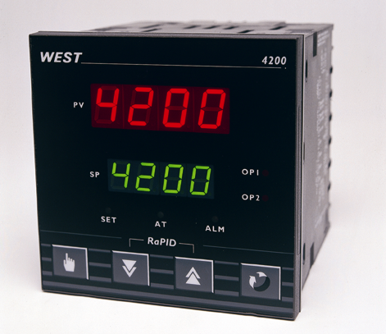
 | The 4200 PID controller’s fuzzy logic algorithm works in the background to reduce overshoot and improve settling times on start-up, setpoint changes and load disturbances.
 | - Heat/Cool operation | - Ramping setpoint
 | - Two process alarms | - Auto-tuning & fuzzy logic
 | - Loop alarm | - Remote setpoint input
 | - RS485 comms | - PC configuration

Technical Data

Features
Control Types | PID with fuzzy logic. Pre-tune, Self-tune, Manual Tuning, or On-Off control. Heat only or heat/cool
Auto/Manual | Selectable from front panel, with bumpless transfer
Output Configuration | Up to 3 total. Max 2 for control (Heat & Cool), max 2 for Alarms,  max 1 for retransmit Process value or Setpoint
Alarm 1 & 2 Types | Process high, process low, SP deviation, band, logical OR and hysteresis. Also 1 loop alarm
Human Interface | 4 button operation, dual 4 digit 13mm & 10mm high LED displays, plus 3 LED indicators
PC Configuration | Off-line configuration from serial port to dedicated config socket (comms option not required)

Input
Thermocouple | J, K, R, S, T, B, L, & N.
RTD | 3 Wire PT100, 50Ω per lead maximum (balanced)
DC Linear | 0-20/4-20mA, 0-50/10-50mV, 0-5/1-5/0-10/2-10V. Scaleable -1999 to 9999, dec point available
Impedance | >100MΩ for Thermocouple and mV ranges, 47KΩ for V ranges and 4.7Ω for mA ranges
Accuracy | +/- 0.25% of input span +/- 1 LSD (T/C CJC better than 0.7°C)
Sampling | 4 per second, 14 bit resolution approximately
Sensor Break Detection | <2 secs (except zero based DC ranges), control O/P’s turn off, high alarms activate for T/C and mV ranges, low alarms activate for RTD, mA or V ranges

Outputs & Options
Control & Alarm Relays | Contacts SPDT 2Amp resistive at 240V AC, >500,000 operations
Control SSR Outputs | Drive capability >4.3V DC in 250Ω (10V 500Ω version available)
Solid State (Triac) Outputs | 0.01 to 1 Amp AC 20 to 280V, 47 to 63Hz
Control DC Outputs | 0-20/4-20mA into 500Ω max, 0-10/0-5V into 500Ω min. Accuracy typically +/- 0.5%
Retransmit Outputs | 0-20/4-20mA into 500Ω max, 0-10/0-5V into 500Ω min. Accuracy typically +/- 0.25%
Communications | 2 Wire RS485, 1200 to 9600 Baud, West ASCII
Dual Setpoint Selection | Selects between 2 SP’s using volt free or TTL input (SP1 = -0.6 to 0.8V, SP2 = 2 to 24V)
Remote Setpoint Input | 0-20/4-20mA, 0-50/0-100mV, 0-5/0-10V or Potentiometer (2KΩ min), scaleable, with external volt free or TTL remote/local setpoint selection input
Operating & Environmental
Temperature & RH | 0 to 55°C (-20 to 80°C storage), 20% to 95%RH non-condensing
Power Supply | 90 to 264V 50/60Hz (optional 20 to 55V AC/22 to 65V DC), approx 4 Watts
Front Panel Protection | IEC IP66 (Behind panel protection is IP20)
Approvals and Certification | CE, UL & ULc

100mm
96mm
96mm
92mm +0.5
92mm +0.5
10mm (approx)

Dimensions

Panel Cut-out

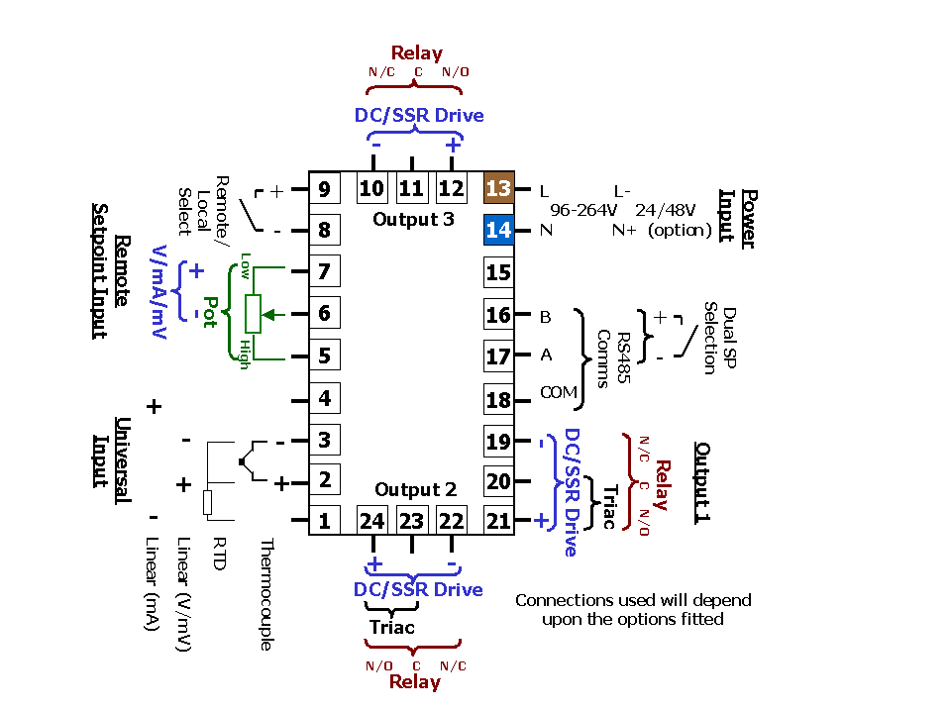

Field Reconfiguration

Connection Details

Input
Configurable to any type, no extra parts required

Output 1
Type is fixed as ordered. Either Relay/SSR (selectable), Triac or DC Linear (selectable for mV, mA, Volts)

Output 2
Configurable as Cool O/P or Alarm via plug-in Relay, SSR, Triac or DC Linear modules

Output 3
Configurable as Alarm via plug-in Relay or SSR modules, or retransmit using DC Linear module

Option Slot
Configurable as RS485 comms or dual setpoint selection, via plug-in modules
Secondary Input
If fitted, can be configured to any input range. Cannot be retro-fitted.

Order Code

 | N4200 | - | x | - | x | - | x | - | x | - | xx | - | x

 | Input type |  |  | Secondary Input
 | 3 Wire RTD or DC mV | 1 |  |  | 0 | Remote Setpoint not required
 | Thermocouple | 2 |  |  | 1 | 0-50/0-100mV Remote Setpoint Input
 | DC mA | 3 |  |  | 3 | 0-20/4-20mA Remote Setpoint Input
 | DC Voltage | 4 |  |  | 4 | 0-5/0-10V Remote Setpoint Input
 | Output 1 |  |  |  | 9 | Potentiometer Remote Setpoint Input
 | Relay Control | 1 |  |  | 8 | *Dual Setpoint
 | DC for SSR Control | 2 |  |  |  | Options and Power Supply
 | DC 0-10V Control | 3 |  |  | 00 | No Options/90-264V AC line supply
 | DC 0-20mA Control | 4 |  |  | 02 | No Options/24-48V AC or DC line supply
 | DC 0-5V SP Control | 5 |  |  | 10 | *RS485 Comms/90-264V AC line supply
 | DC 4-20mA Control | 7 |  |  | 12 | *RS485 Comms/24-48V AC or DC supply
 | Output 2 |  |  |  | 30 | *Dual Setpoint/90-264V AC line supply
 | Not fitted | 0 |  |  | 32 | *Dual Setpoint/24-48V AC or DC supply
 | Relay Control or Alarm 2 | 1 |  |  |  | Output 3
 | DC for SSR Control or Alarm 2 | 2 |  |  | 0 | Not fitted
 | DC 0-10V Control | 3 |  |  | 1 | Relay Alarm 1 output
 | DC 0-20mA Control | 4 |  |  | 2 | DC for SSR Alarm 1 output
 | DC 0-5V Control | 5 |  |  | 3 | DC 0-10V Re-Transmit PV or SP
 | DC 4-20mA Control | 7 |  |  | 4 | DC 0-20mA Re-Transmit PV or SP
 | Triac Control | 8 |  |  | 5 | DC 0-5V Re-Transmit PV or SP
 |  |  |  |  | 7 | DC 4-20mA Re-Transmit PV or SP
*If both dual setpoint selection and comms are required, select Options code 10 or 12 and Secondary Input code 8

In accordance with our policy of continuous improvement, we reserve the right to change specifications from those shown in this document.

West Instruments Ltd

The Hyde Business Park Tel: +44 (0)1273 606271

Brighton, BN2 4JU Fax: +44 (0)1273 609990

East Sussex e-mail: info@west-inst.co.uk

England www.west-inst.co.uk

